Hospital Management System (HMS) database project is essential for understanding the system's design, functionality, and how it operates. Below, I'll provide you with a template for a comprehensive DBMS (Database Management System) project documentation for a Hospital Management System. You can customize and expand upon this template as needed.

## Table of Contents

1. **Introduction**

- Purpose of the Documentation

- Project Overview

- Project Team

2. **Database Schema**

- Entity-Relationship Diagram (ERD)

- Database Tables

- Table 1: Patients

- Table 2: Doctors

- Table 3: Appointments

- Table 4: Medical Records

- Table 5: Departments

- Table 6: Staff

- ...

3. **Data Dictionary**

- Field Definitions

- Data Types

- Primary and Foreign Keys

4. **Database Design**

- Normalization

- Indexing

- Constraints

- Triggers

- Views

- Stored Procedures

5. **User Roles and Permissions**

- Admin

- Doctor

- Nurse

- Receptionist

- Patient

- ...

6. **Data Flow Diagram**

- User Interactions

- Data Processing

7. **User Interfaces**

- Screenshots and Descriptions

- Navigation Flow

8. **System Functionality**

- Registration and Login

- Appointment Scheduling

- Patient Management

- Doctor Management

- Billing and Invoicing

- ...

9. **Data Security**

- Authentication

- Authorization

- Encryption

10. **Backup and Recovery**

- Data Backup Procedures

- Disaster Recovery Plan

11. **Deployment**

- Server Configuration

- System Installation

12. **Maintenance and Upgrades**

- Routine Maintenance

- Version Updates

13. **Testing**

- Test Cases

- Test Results

14. **Performance Optimization**

- Query Optimization

- Resource Monitoring

15. **Troubleshooting**

- Common Issues

- Solutions

16. **User Training**

- Training Materials

- User Manuals

17. **Appendices**

- Sample SQL Queries

- Glossary

- References

## 1. Introduction

### Purpose of the Documentation

The purpose of this documentation is to provide a comprehensive overview of the Hospital Management System (HMS) database project. It serves as a reference for project stakeholders, developers, administrators, and end-users.

### Project Overview

The Hospital Management System is designed to streamline hospital operations, including patient management, appointment scheduling, medical records, and more. It aims to enhance efficiency, accuracy, and patient care.

### Project Team

- Project Manager: [Name]

- Database Developer: [Name]

- UI/UX Designer: [Name]

- Testers: [Names]

- ...

## 2. Database Schema

### Entity-Relationship Diagram (ERD)

[Include an ERD diagram illustrating the relationships between database entities.]

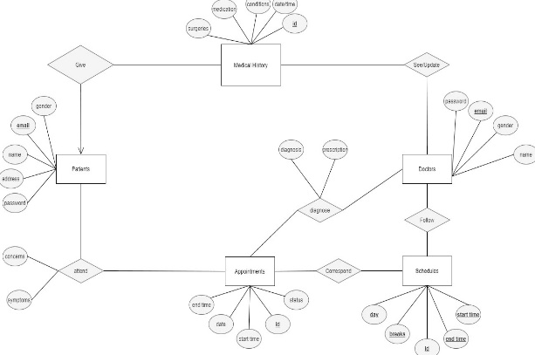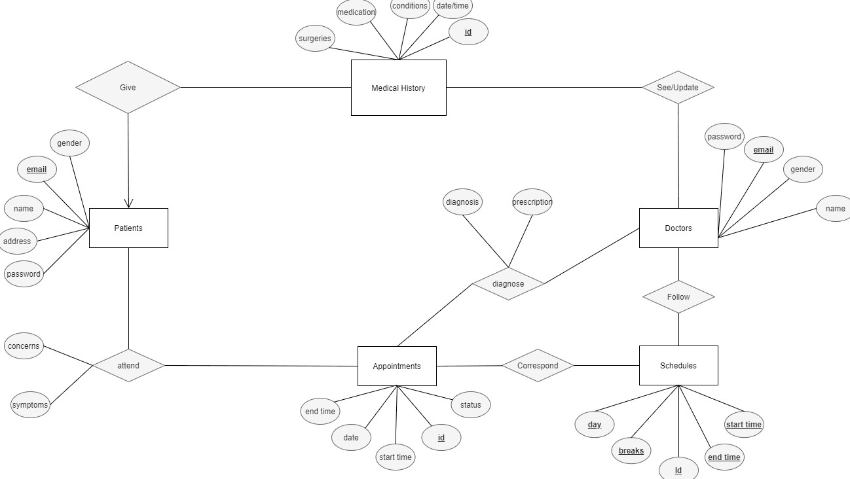

Database Tables

#### Table 1: Patients

- Fields: [patient id, patient name, patient age, Gender, email, Address]

- Primary Key: Patient ID

#### Table 2: Doctors

- Fields: [Doctor ID, Doctor Name, specialization, email, Address]

- Primary Key: Doctor ID

#### Table 3: Appointments

- Fields: [Appointment Id, Patient Id, Appointment Date, status]

Foreign key : Doctor id, patient id

#### Table 4: Medical Record

-Fields: [Record id, patient id, doctor id, Record date, Diagnosis, prescription]

#### Table 5: Billing Table

- Fields: Bill Id, patient id, Bill Date, Total Amount, payment method]

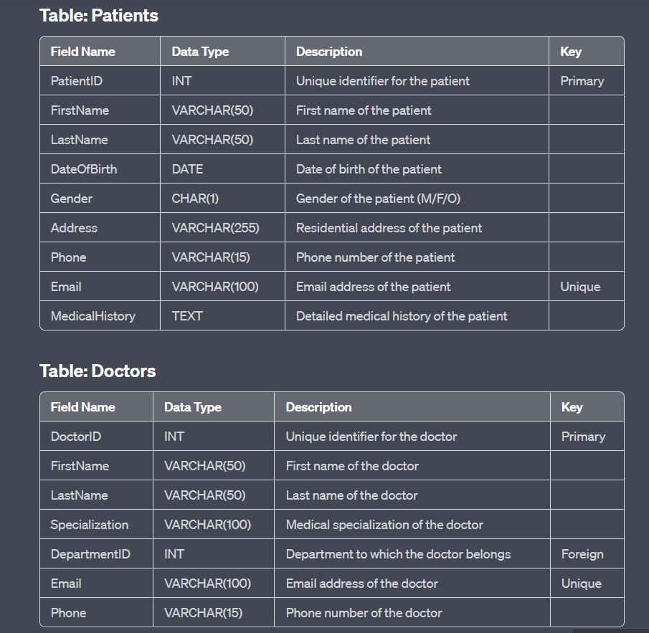## 3. Data Dictionary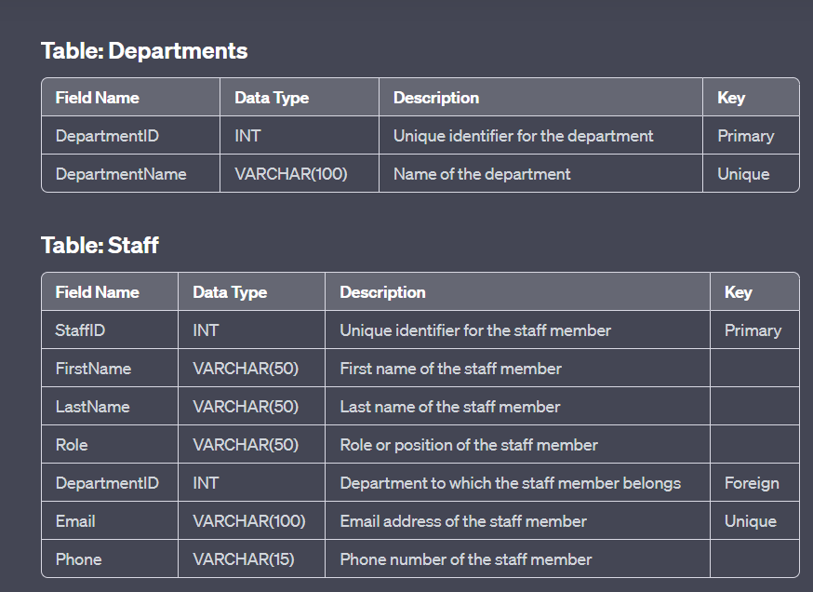

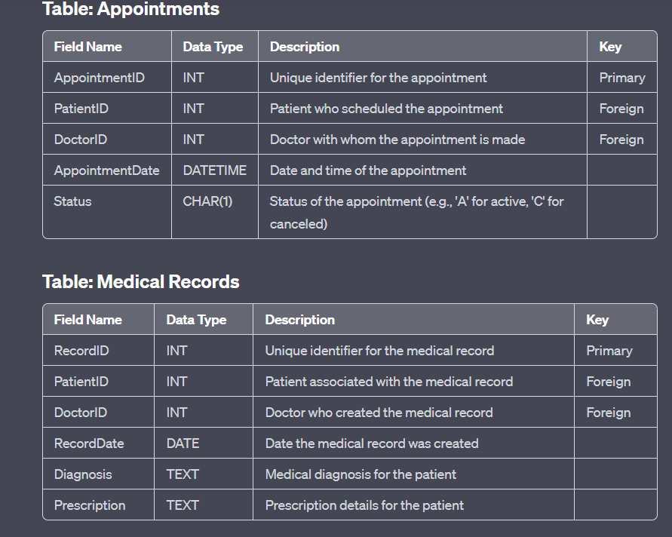

## 4. Database Design

Certainly, I'll explain the design principles, normalization, indexing, constraints, triggers, views, and stored procedures that could be used in the database for the Hospital Management System (HMS) example provided earlier.

### Design Principles

1. **Normalization**:

- The database should be normalized to reduce redundancy and maintain data integrity. This ensures that data is stored efficiently and updates are made consistently.

2. **Data Integrity**:

- Enforce referential integrity to maintain relationships between tables.

- Use constraints to prevent invalid data entry.

3. **Scalability**:

- Design the database to handle a growing amount of data and users.

4. **Security**:

- Implement strong security measures, including user authentication and authorization.

5. **Performance**:

- Optimize query performance through indexing and efficient data retrieval.

### Normalization

Normalization is the process of organizing data in a database to reduce redundancy and dependency. In the HMS example:

- The "Patients" table can be normalized to remove redundant patient data.

- The "Doctors" table can have a foreign key reference to the "Departments" table to eliminate department information redundancy.

- "Appointments" can be linked to patients and doctors through foreign keys.

### Indexing

Indexing is used to improve data retrieval performance. In the HMS example:

- Indexes can be added to the primary keys (e.g., PatientID, DoctorID) for quick record retrieval.

- Indexes on commonly searched fields like "Email" in the "Patients" and "Doctors" tables can improve search speed.

### Constraints

Constraints are rules applied to the database to maintain data integrity. In the HMS example:

- Foreign key constraints ensure that relationships between tables are maintained (e.g., PatientID and DoctorID in "Appointments" must exist in "Patients" and "Doctors").

- Unique constraints ensure email addresses in the "Patients," "Doctors," and "Staff" tables are unique.

### Triggers

Triggers are used to automatically execute actions in response to specific database events. In the HMS example:

- A trigger can be implemented to update the "Appointment" status when a scheduled appointment time has passed or when a patient cancels.

- Triggers can enforce business rules, such as ensuring a doctor cannot be assigned to overlapping appointments.

## 5. User Roles and Permissions

### Views

Views are virtual tables created as the result of a query. In the HMS example:

- A view can be created to consolidate patient and appointment information, simplifying reporting.

- Another view can display a list of available appointment slots for each doctor.

### Stored Procedures

Stored procedures are precompiled SQL scripts that can be executed within the database. In the HMS example:

- A stored procedure can be created to schedule an appointment, ensuring proper validation and business logic.

- Another stored procedure can calculate statistics, such as the number of appointments per doctor, which can be used for reporting.

## 6. Data Flow Diagram

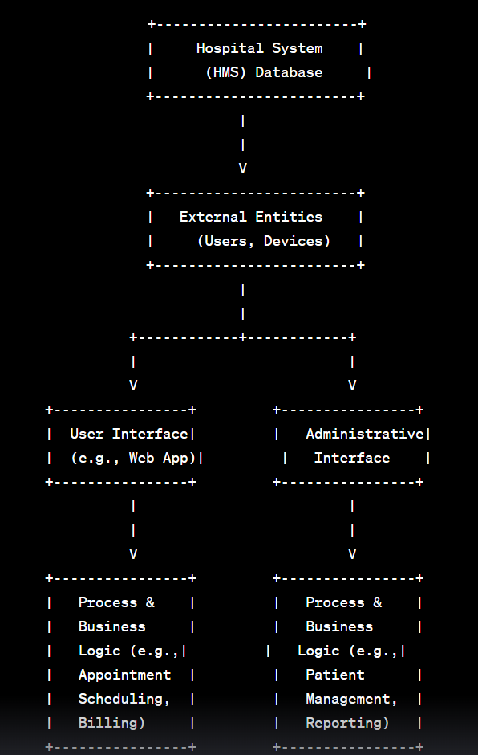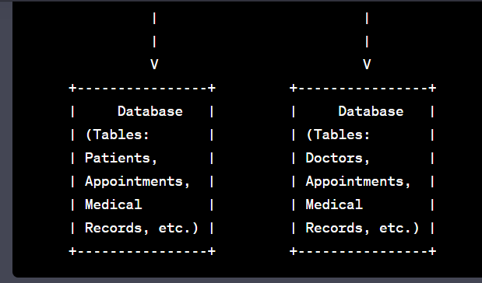

### 7. User Interfaces

In this section, you should include screenshots and descriptions of the user interfaces used in your Hospital Management System (HMS). You can provide images of login screens, appointment scheduling screens, patient management screens, and any other relevant user interfaces. Alongside each screenshot, add descriptions to explain the purpose and functionality of each interface.

### 8. System Functionality

Describe the key functionalities of your HMS in detail. This section should cover all the features and operations the system supports, such as:

- **Registration and Login:** Explain how users register and log in to the system.

- **Appointment Scheduling:** Detail the process of scheduling, modifying, and canceling appointments.

- **Patient Management:** Describe how patient records are created, updated, and managed.

- **Doctor Management:** Explain how doctors' information and schedules are managed.

- **Billing and Invoicing:** Provide an overview of the billing process, including generating invoices and recording payments.

- **Medical Records:** Describe how medical records are created, accessed, and updated.

- **Reporting:** Explain any reporting or analytics features in the system.

### 9. Data Security

This section should discuss the security measures in place to protect the HMS data:

- **Authentication:** Explain how users are authenticated when accessing the system.

- **Authorization:** Describe how permissions are assigned and enforced, ensuring users can only access data and perform actions they are authorized for.

- **Encryption:** Detail how data at rest and in transit is encrypted to prevent unauthorized access.

### 10. Backup and Recovery

Here, you should outline procedures for data backup and disaster recovery to ensure data availability and integrity:

- **Data Backup Procedures:** Describe how data is regularly backed up, including the frequency and storage locations.

- **Disaster Recovery Plan:** Explain the steps to be taken in the event of data loss or system failure, including recovery from backups.

### 11. Deployment

Provide instructions for setting up and deploying the HMS:

- **Server Configuration:** Detail the server requirements and configurations needed to run the system.

- **System Installation:** Explain how to install and configure the HMS software on the server.

### 12. Maintenance and Upgrades

Explain how routine maintenance is carried out and how version updates are managed:

- **Routine Maintenance Procedures:** Describe regular tasks such as database optimization, server monitoring, and security updates.

- **Version Updates:** Explain how new versions of the system are released, tested, and deployed.

### 13. Testing

Outline the testing phase of your project:

- **Test Cases:** Provide a list of test cases that were used to ensure the system functions correctly.

- **Test Results:** Describe the results of the testing phase, including any issues identified and their resolutions.

### 14. Performance Optimization

Discuss measures taken to optimize system performance:

- **Query Optimization:** Explain how database queries are optimized for efficiency.

- **Resource Monitoring:** Detail how system resources are monitored to ensure smooth operation.

### 15. Troubleshooting

Provide solutions for common issues that users or administrators may encounter when using the HMS.

### 16. User Training

Include materials and manuals for user training, such as user guides or tutorials, to help users navigate and utilize the system effectively.

### 17. Appendices

Include any additional information that doesn't fit into the previous sections, such as:

- **Sample SQL Queries:** Provide examples of common SQL queries used in the system.

- **Glossary:** Define key terms and acronyms used in the documentation.

- **References:** List any external sources or references used during the development of the HMS.